DOMAIN :IOT

# ASSIGNMENT-3

NAME. : Keerthivasan.R

REGISTERNUMBER 714019106047

COLLEGE. :SRISHAKTHIINSTITUTEOFENGINEERINGANDTECHNOLOGY



PROGRAMFORTRAFFICLIGHT

PythonCode:

voidsetup(){

//putyoursetupcodehere,torunonce:Serial1.begin (9600);

pinMode(21, OUTPUT);pinMode(20, OUTPUT);pinMode(19,O UTPUT);

}

voidloop(){

//putyourmaincodehere,torunrepeatedly:digitalWrite(2 1,HIGH);

delay(3000);//thisspeedsupthesimulationdigitalWrite( 21,LOW);

digitalWrite(20,HIGH);delay( 3000);digitalWrite(20, LOW);digitalWrite(19,HIGH); delay(3000);digitalWrite(19, LOW);

}



OUTPUT:

TrafficLightsForRaspberryPiBlinking RedLight:

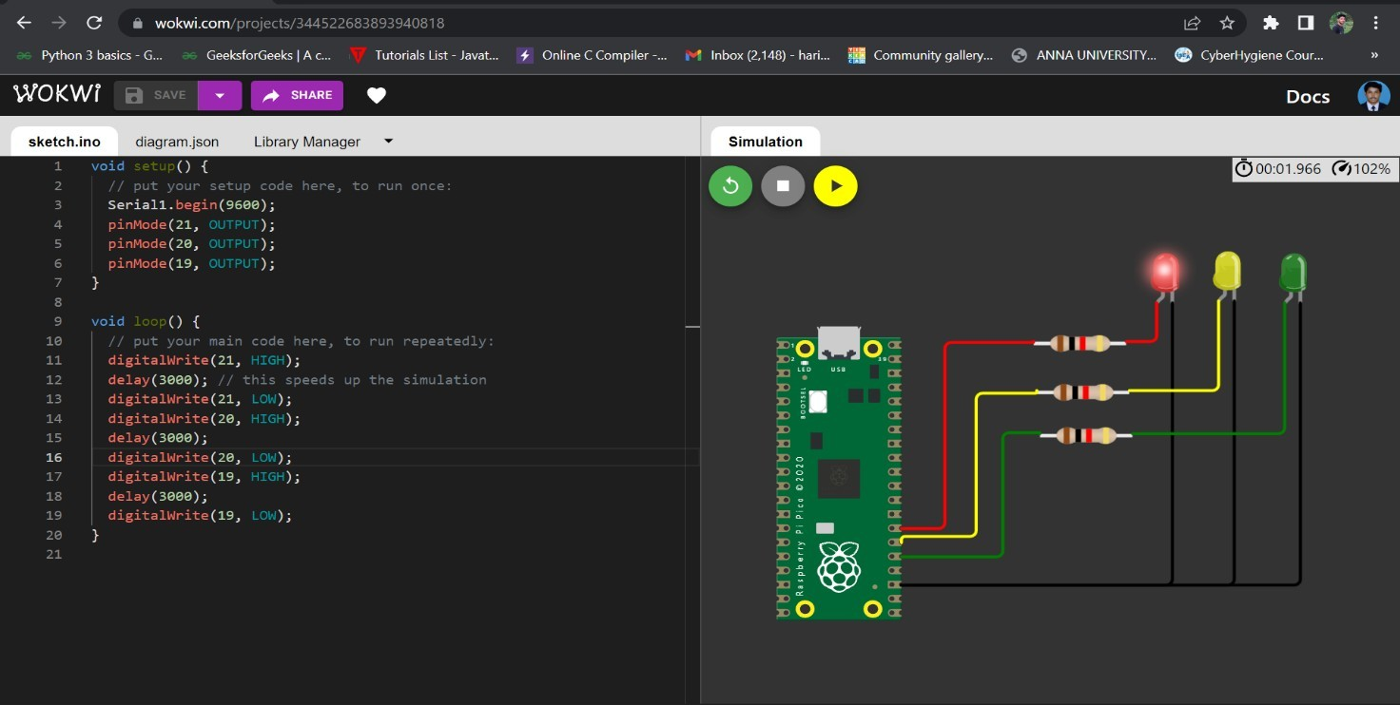

BlinkingYellowLight:

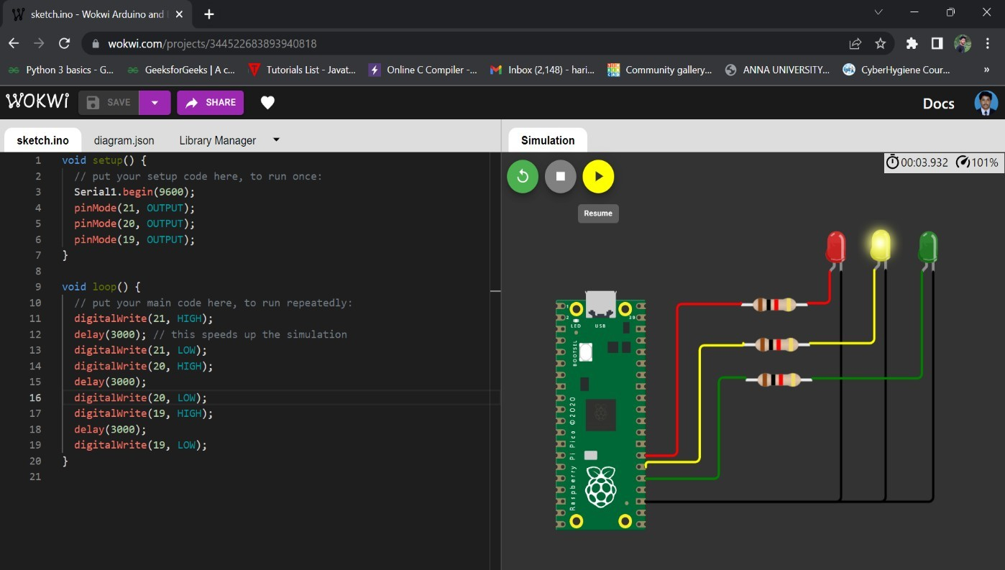



BlinkingGreenLight:

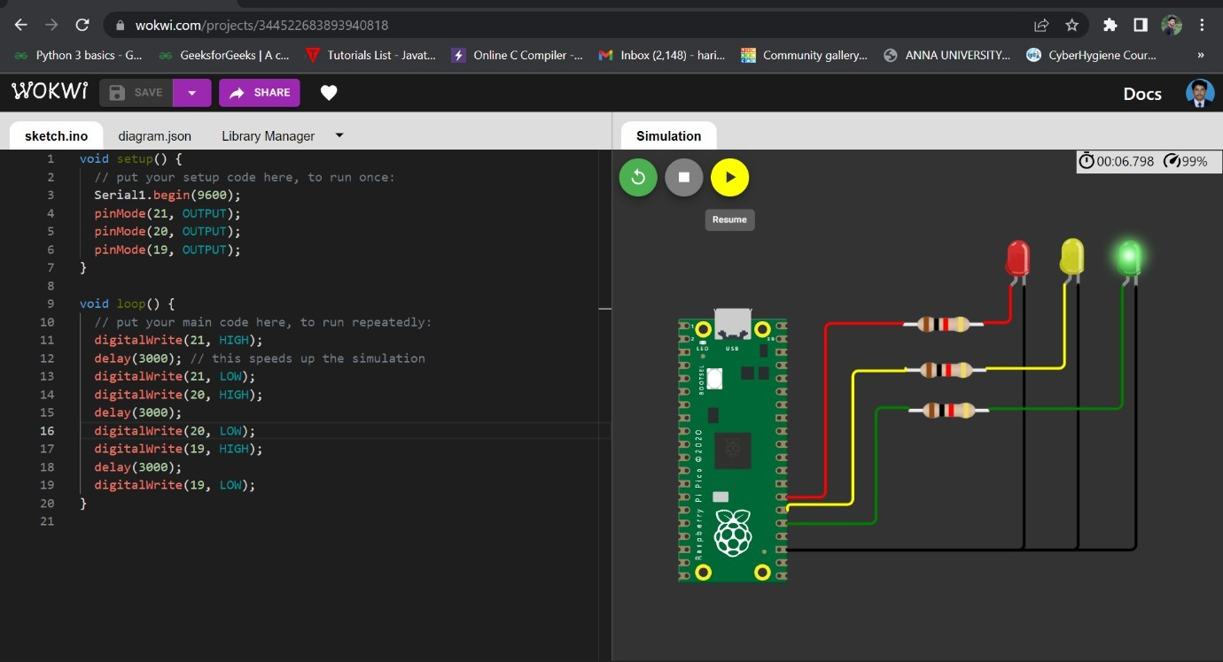

# BLINKINGLED:

PROGRAMFORBLINKINGLED



Pythoncode:

voidsetup(){

//putyoursetupcodehere,torunonce: Serial.begin(9600);pinMode (22,OUTPUT);

}

voidloop(){

//putyourmaincodehere,torunrepeatedly:digitalWrite(2 2,HIGH);

Serial.println("LED ON");delay(2000);digitalWrite(2 2,

LOW);Serial.println("LEDOFF");d elay(2000);

}

Output: BlinkingLEDForRaspberrypi:

